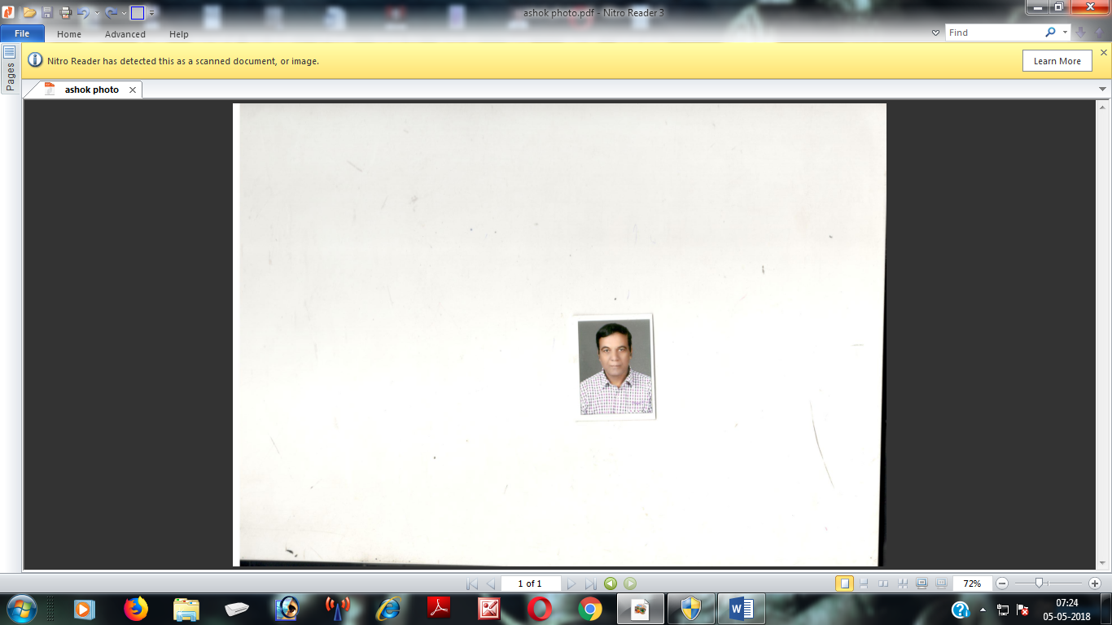
R E S U M E

POST APPLIED FOR : Mechanical Engineer

NAME : ASHOK DWIVEDI

FATHER’S NAME : Sh. AmritLalDwivedi

DATE OF BIRTH : 30th July, 1962

POSTAL & PERMAMENT ADDRESS : H.No. 86, Double Storey,
Sonepat-131001
(Haryana)
Ph .9896667593, 9416556494,
9518179812

QUALIFICATION : Matric Passed from HBSE Board Haryana
in 1977
PROFESSIONAL : Three Years Diploma Course in
Mechanical Engg. From Haryana
Board of Technical Education,
Chandigarh (Haryana) in 1980.

Experience :

In Nutshell I have 30Years of Experience in Tool Room , Mech. Maintenance, Fabrication, accordingly achieved more results of production and quality products.

ATLAS CYCLE (HARYANA) LTD. (FROM 2010 TO TILL DATE)
Asstt. Manager ( Maintenance)
Atlas Cycle is a ISO . 9001,2000 certified Manufacturing cycle Product.

Job Profile :
- Controlling of ISO Documents.
- Preventive Maint&Runing breakdown responsibility like shaper, Milling Planner,lathe,Radial Drilling, Press Shop, Paint Plant ,Boiler, Furnace, Tube-well, Rim Plant.

Achievements :
- Reduce the rejection by maintain the all machine in time.
- To learn the man power to operate and Maint. Of machine safely.
- Tackle the men Power to reduce theabsenteeism.

From 1992 to 2010

Worked with “VIJ ENGINEERING PVT. LTD.” PANIPAT (Fabrication of telecom Tower like AirTel, Idea, BSNL, Vodafone.As a Senior Mech. Engg.

Job Profile :

- Preventive Maint&Runing breakdown of galvanizing plant, power Prees, shaper ,Milling, Lathe, Drilling.
- Inspection of Product sample.

Achievements :

- Reduce the rejection by maintaining the line of production
- To learn the man power to operate and Maint. Of machine safely.
- Tackle the men Power to reduce theabsenteeism.

From 1989 TO 1992.

Worked with “UPPER INDIA PVT. LTD.” Delhi is a workshop for servicing the Hero Honda Motorcycle as a works manager.

Job Profile :

- Timely deliver the Bike After Servicing .
- Spares availability .

Achievement

- Reduce the maintenance
- Customer satisfaction .

From 1986 TO 1989.

Worked with “PARLE BISCUITS PVT. LTD.”.BAHADURGARH, manufacturing of Parle Biscuit as a Engg. (Maint.)

Job Profile :

- Responsible of workshop machine like Lathe ,Milling,shaper,Drilling& Power hacksaw
- Preventive maint. Of Mixing Plant, Oven, Wire band, electro- mechanical packing machine.

Achievement

- Reduce the percentage of maintenance.
- Learn the man power to operate the machine
- Tackle the man power to reduce the absenteeism.

From 1983 TO 1986

Worked with “KELVINATOR OF INDIA LTD..”BALLABHGARH .manufacturing of
Referigerator as a Foreman (Tool Room).

Job Profile :

- Manufacturing Press Tools ,Dies, Jigs, Fixtures,
- Gauges manufacturing for Inspection the product.
.

Achievements :

- Tackle the man power
- Reduce the rejection of product by gauge controlling .

From 1980 TO 1983

Worked with “EVEREST TOOLS LTD. .”Sonepat manufacturing hand Toolsas a Supervisor (Tool Room).

Job Profile :

- Manufacturing Press Tools ,Dies, Jigs, Fixtures,
- Gauges manufacturing for Inspection the product.
.

Achievements :

- Tackle the man power
- Reduce the rejection of product by gauge controlling .

SAILIENT FEATURES :

- Through knowledge of company wide quality movements like quality circle, suggestion schemes, quality improvement projects.
- Knowledge of quality system like ISO-9001.
- Knowledge of statistical methods & good organizations, planning abilities.
- Habitual of process control & trouble shooting.

EXTRA CURRICULAR ACTIVITIES :

Games : A good player of Cricket, T.T. and Badminton
Salary Expected : Negotiable

( ASHOK DWIVEDI )

